**Johnson Counter**

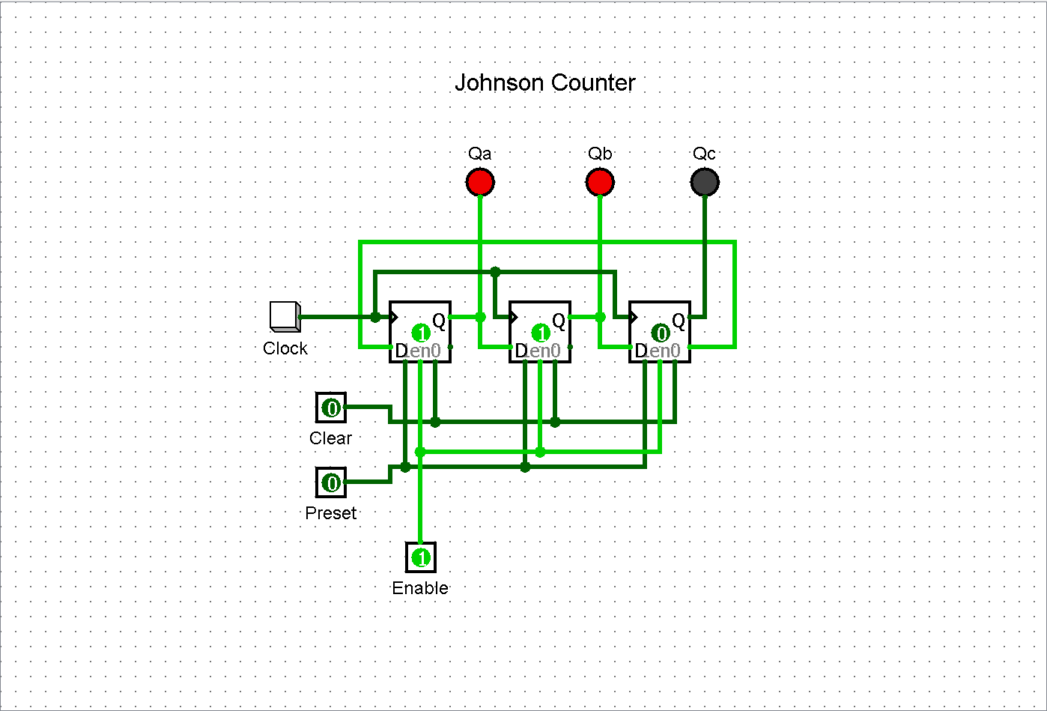

**Parallel In Parallel Out Shift Register**

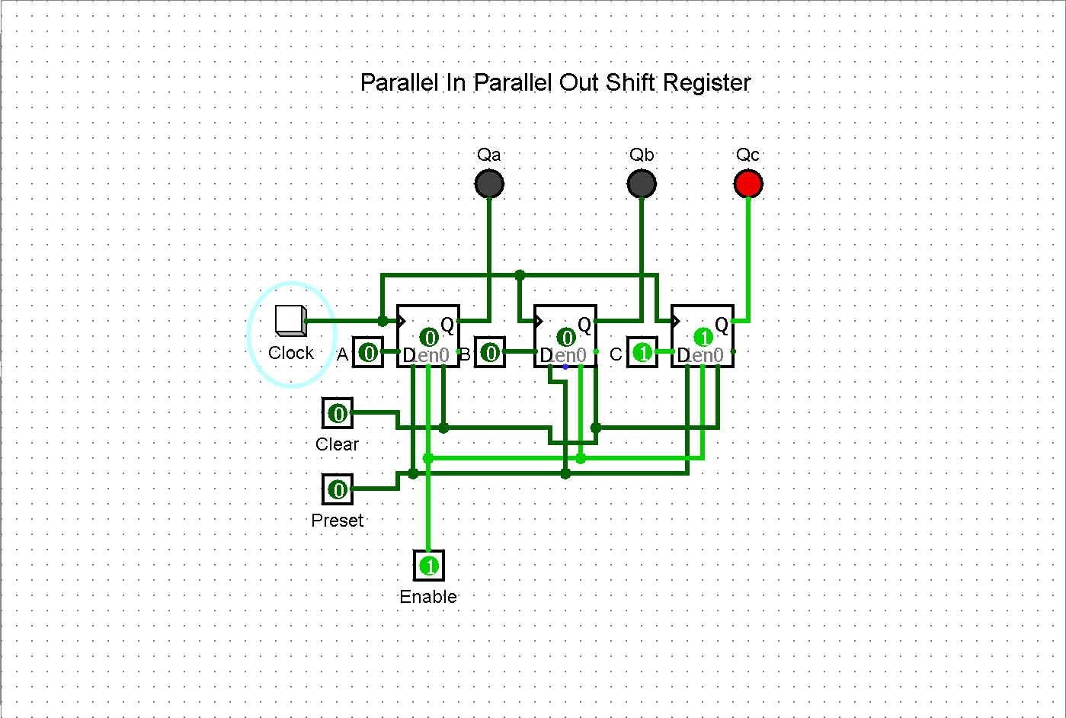

**Serial In Serial Out Shift Register**

